Task 2

Execute the following network commands like ip config,tracert,telnet,netsh,ping,nslookup and netstat

Ipconfig =

Procedure

Step 1:- Launch cisco packet tracer

double click cisco packet tracer or find it in your application list and open the program

Create a simple network topology.

1. Add devices – routers and switches, pc.
2. Drag and drop router and switches on to the workspace.
3. Drag and drop two pc on to the workspace.
4. Use connection tool to connect the devices.
5. Connect one pc to the switch using the copper straight through cable.
6. Conect the switch to the router using another copper straight through cable.
7. Connect the second pc by copper straight through cable.
8. Configure router.
9. Click on the router go to config tab
10. Assign Ip address to the router interface. Ex= interface G0/0: Ip address 192.168.1.1
11. The same way we have to assign to pc2 but different Ip address.
12. Configure of pc.
13. Click on each pc, go to the desktop option and then ip configuration
14. Assign config address to each pc.

Ex Pc1 : Ip address 192.168.1.2

Subnet mask 255.255.255.0

Default Gateway 192.168.2.2

Ex Pc2 : Ip address 192.168.0.2

Subnet mask 255.255.255.0

Default Gateway 192.168.1.2

1. Excution network command
2. Click on pc1, go to desktop.
3. Open command prompt in pc1.
4. Type “ipconfig”
5. The output will look like

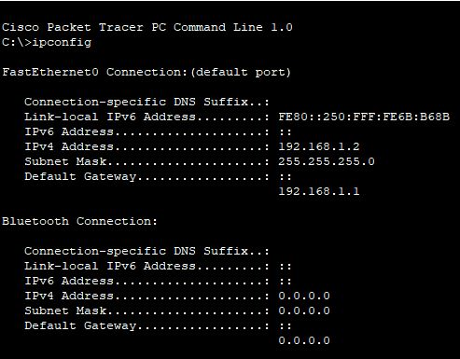

Tracert

1. Type tracert and give the ip address of that pc and press enter.
2. It traces the path taken to destination by sending icmp echo request message.

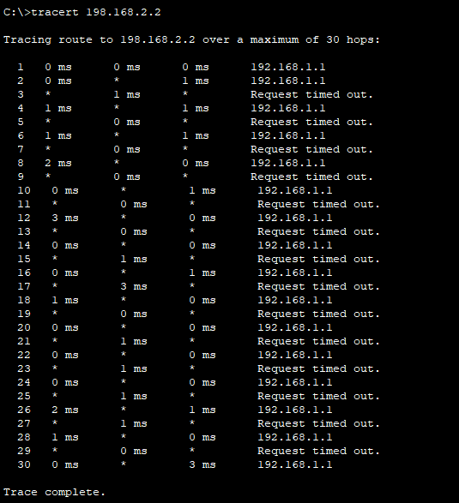

Telnet

Assign IP Address

* Click on the router
* Go to the Config tab
* Select the interface connected to the switch (eg G0/0).
* Assign IP address: 192.168.1.1 , subnet Mask :- 255.255.255.0
* Router >enable
* Router>config terminal
* Router(config-if) # line vty 0 4
* Router(config-line)#password cisco
* Router(config-line)#login
* Router(config-line)#exit
* Router(config)#end
* Router #
* %SYS -5- CONFIG_1: configured from console by console
* Router #write memory
* Building configuration
* [ok]

Telnet from Pc to Router

1. Open Command Prompt

On the PC0,go to the Desktop tab and open command prompt

2 . Execute Telnet Command:

Enabling telnet on a real router:- if using real equipment , make sure telnet is enabled and the device is configured of a computer.

Router configuration and brief Ip interface

This command is a script utility that allows you to display or modify the network configuration of a computer.

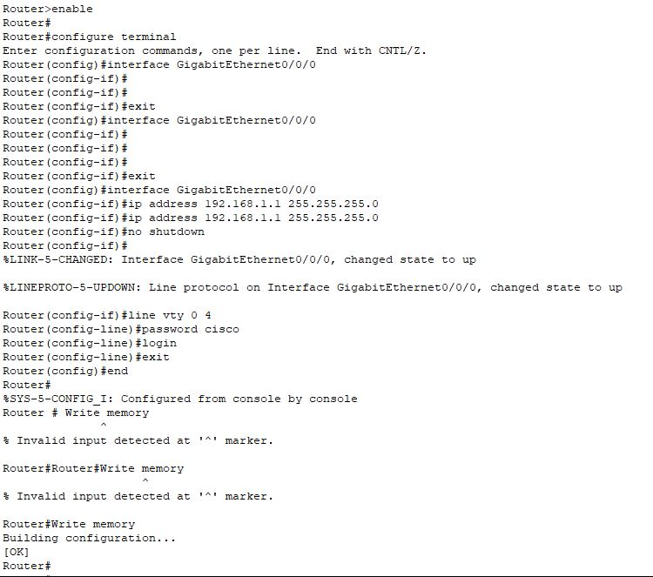

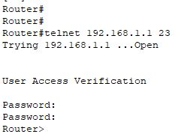

Ping 192.168.2.2

ICMP Echo

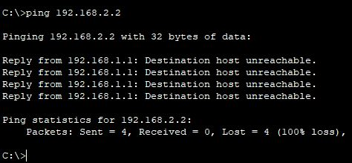

Nslooup

This command queries the dns to obtain name or Ip address mapping

To use the nslookup command to resolve a domain name to an ip address in cisco packet tracer,you’ll need to ensure that the dns server is properly configured in your network topology

1. Add one server(to act as a dns server)
2. Connect both pcs and the server to the switch using copper straight – through cables.

Configure the dns server

Assign Ip address

* Click on the server
* Go to the Config tab and select the FastEthernet0 interface.
* Assign IP address: 192.168.1.3, Subnet Mask: 255.255.255.0, Default Gateway : 192.168.1.1
* Configure dns service:
* Go to the service tab on the server
* Select dns and turn the service on.
* Add an entry for [www.google.com](http://www.google.com) with IP address(eg 8.8.8.8)

Use the nslookup command

1. Open command and prompt on pc0

Go to the desktop tab on pc0

Open the command prompt:

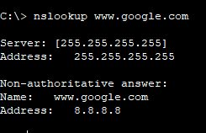

Dns server configuration : ensure that the dns server is correctly configured and running.

Dns entries: the dns entry for [www.google.com](http://www.google.com) should be added to the dns server with an IP address

Network configuration :- ensure that all devices are correctly connected and configured with appropriate IP addresses, subnet masks and default gateways



Netstat

This command displays network connections for the transmission control protocol(TCP) , routing tables, and a number of network interface and network protocol statistics

The netstat command is used to display network connections, routing tables ,Interface statistics , masquerade connections and multicast memberships

Cisco screenshot

